**Query 3 sem index:**

SELECT T.name_team, P.name_project, MAX(S.amount_sale_project)

FROM team as T NATURAL JOIN sale as S NATURAL JOIN project as P

WHERE T.idt_project = P.idt_project AND P.idt_project = S.idt_project

GROUP BY T.name_team, P.name_project

HAVING MAX(S.amount_sale_project)>=ALL(

SELECT amount_sale_project

FROM sale)

Relatório do plano de consulta a partir do comando explain do Postgress:

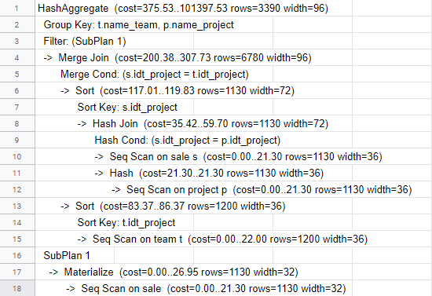

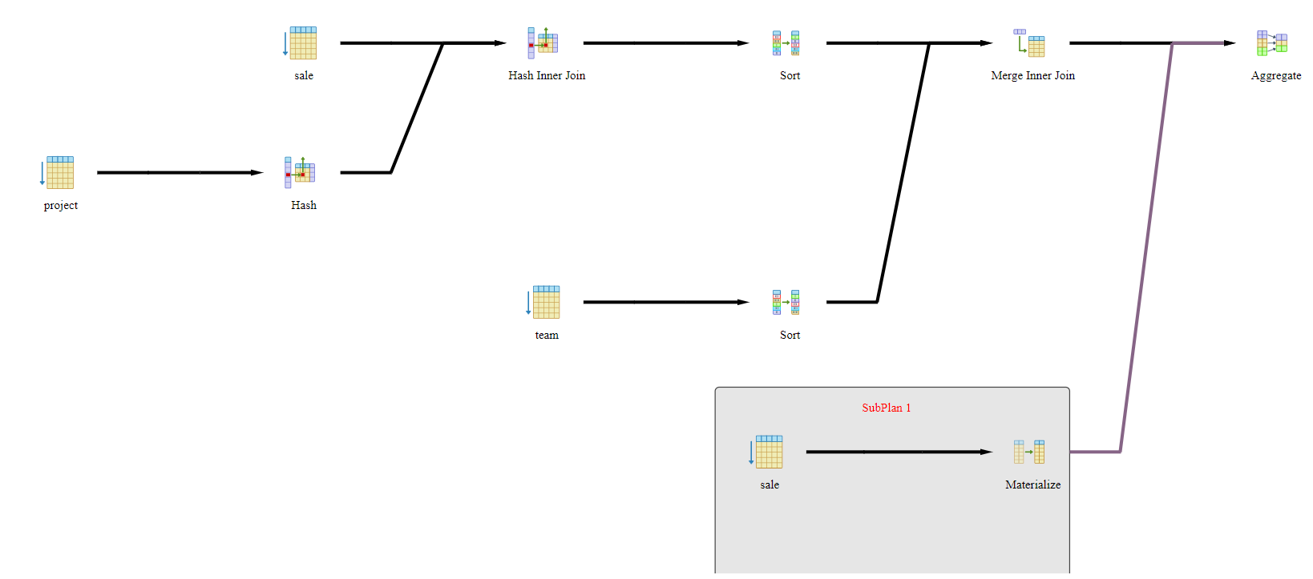

**query 3 com index:**

CREATE INDEX indiceTerceiraQuery

ON sale (amount_sale_project);

CREATE INDEX indiceTerceiraQueryProject

ON project (idt_project);

Relatório do plano de consulta a partir do comando explain do Postgress:

